Pre-Course Writing Test
Name:
Date:



SECTION A: Sentence Accuracy & Micro-Writing /

Task Al. Error Correction (10 points total)

Rewrite each sentence below in correct, professional English. Each item is worth 2 points. / 2 kc
o
1 . Thank you for your email. I am checking the matter but need more informations from colleague.

2* The attached file is not same version that we discussed in last meeting.
- Please confirm me if the applicant have already submitted the missing documents.
p
do

- We will update you about the situation as soon as possible, but today is difficult because many works.
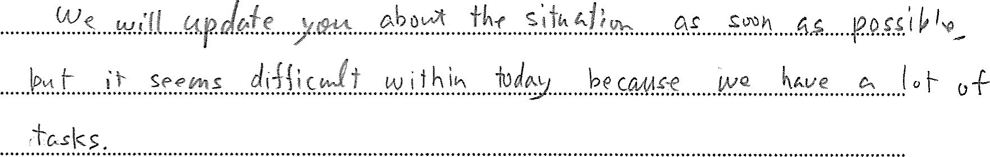

- I would appreciate if you can check again the below points and give me your advices.
Could
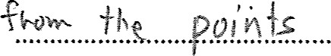be(ow &.i.vg.....m.g......y...our advice ,

Task A2. Micro-Writing (15 points total)

Write 1-2 professionally appropriate sentences for each prompt. Each item is worth 5 points. /

5 kc30
1 . Inform a foreign counterpart that you need two extra days to prepare a response. /

- Request clarification about a contradictory section of an international guideline. /
- Explain that you have attached a corrected verslon of a notice. /修正済みの

通知文を添付したことを伝えてください。
A。ムノ ー豸広・co「にぐり/ゾe价引び、、 ハ0 ⅱ

SECTION B: Task-Based Writing /
Task Bl. Email to a Foreign Office (25 points)

Write a 120-160 word email to an EPO officer requesting clarification about a difference in document submission requirements. This task is worth 25 points. /
EPO

25 kC30
Include / : Purpose of inquiry / ä fi
- Short background /
Specific questions /
Deadline /
- Professional tone /
rmal<L
ccdnrc O p O and
0

Ctct e



Task B2. Administrative Explanation (25 points)

Write a 100-130 word internal explanation describing a new step added to an administrative process for handling foreign applicants. /
(100—130 as)
Include /  : - What changed / - Why it matters /
- What staff should do /
A nog.' |  |  | 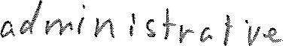 | Cez | 
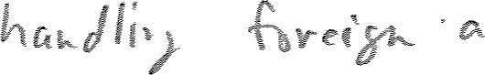 | licrznfr | (p | s
 |  htts | To | Su 

6


sctlo 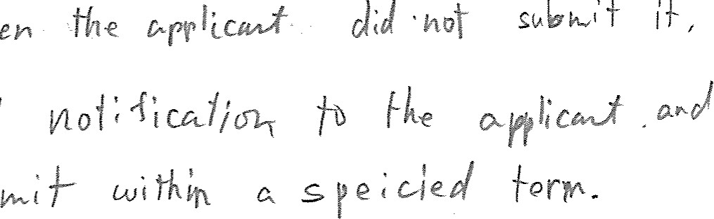

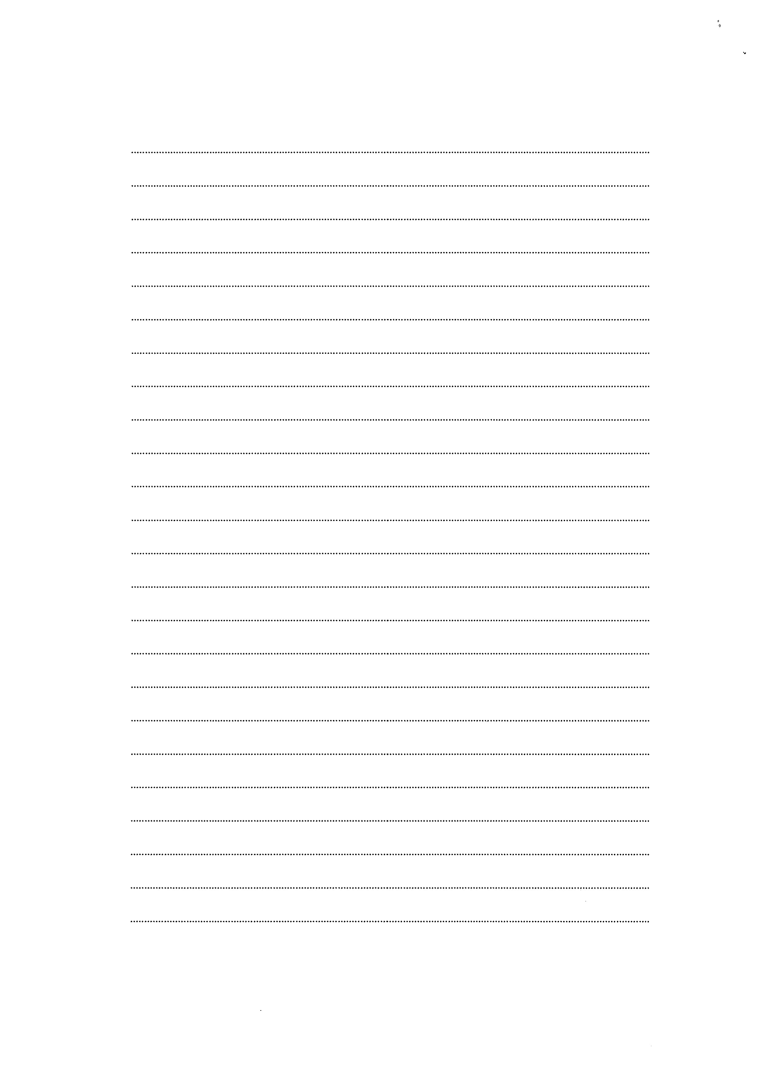

SECTION C: Revision & Editing /

Task Cl. Rewriting (25 points)

Rewrite the email below to make it clear, professional, and logically structured. /
Dear colleague,
I reviewed your draft but several parts were unclear, and I was not able to understand the procedure.
The applicant has already contacted us twice, and we have not been able to respond because we do not yet have an accurate explanation. Please review the instructions again and provide the correct procedure as soon as possible, as the deadline is approaching.
Thank you.
D
40md



